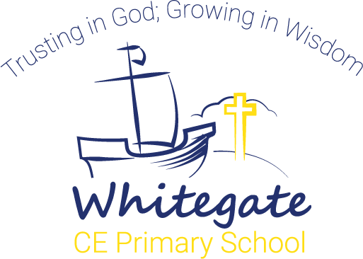
Whitegate Computing Curriculum

Hawthorn Class
Digital Literacy | E Safety | - Identify personal information that should be kept private.  - Question the ‘validity’ of what they see on the Internet.  - Recognise online behaviours that would be unfair, how they can be avoided and what to do when they are encountered.  - Understand why age ratings for games (eg. PEGI) and for commonly used apps exist and how they keep them safe.  - Tell an adult if anything worries them online.  - Identify dangers when presented with scenarios, social networking profiles, etc.  - Articulate examples of ‘good’ and ‘bad’ behaviour online.
 | Research | - Type in a URL to find a website.  - Use a search engine to find a range of media, e.g. images and text.  - Understand Internet safety rules.  - Identify the ways we communicate online.  - Explain who will be able to read my communication.  - Explain why we need to be responsible online.
Computer Science | Programming | - Create, test and debug algorithms that accomplish a specific goal in Scratch Jr using a range of commands including:  - move, rotate and repeat  - sound  - changes to a background or character
Information Technology | Word processing | - Access and open a word processing document.  - Highlight/select items.  - Use cut, copy and paste.  - Enter text.  - Use upper and lower case letters.  - Use the ‘shift’, ‘caps lock’ and ‘space’ correctly.  - Use the return key.  - Understand how to edit using ‘backspace’, ‘delete’, ‘arrow keys’ and ‘undo/redo.’ if they have mistyped or repeated a letter.  - Word process short texts using word lists.  - Understand how text can be saved and retrieved.  - Change the font style, size and colour.  - Use the cursor (arrow) keys for simple on screen editing.  - Import graphics and add text, with support.  - Use the spell checker.  - Use Page Setup to choose Portrait or Landscape page as appropriate.

