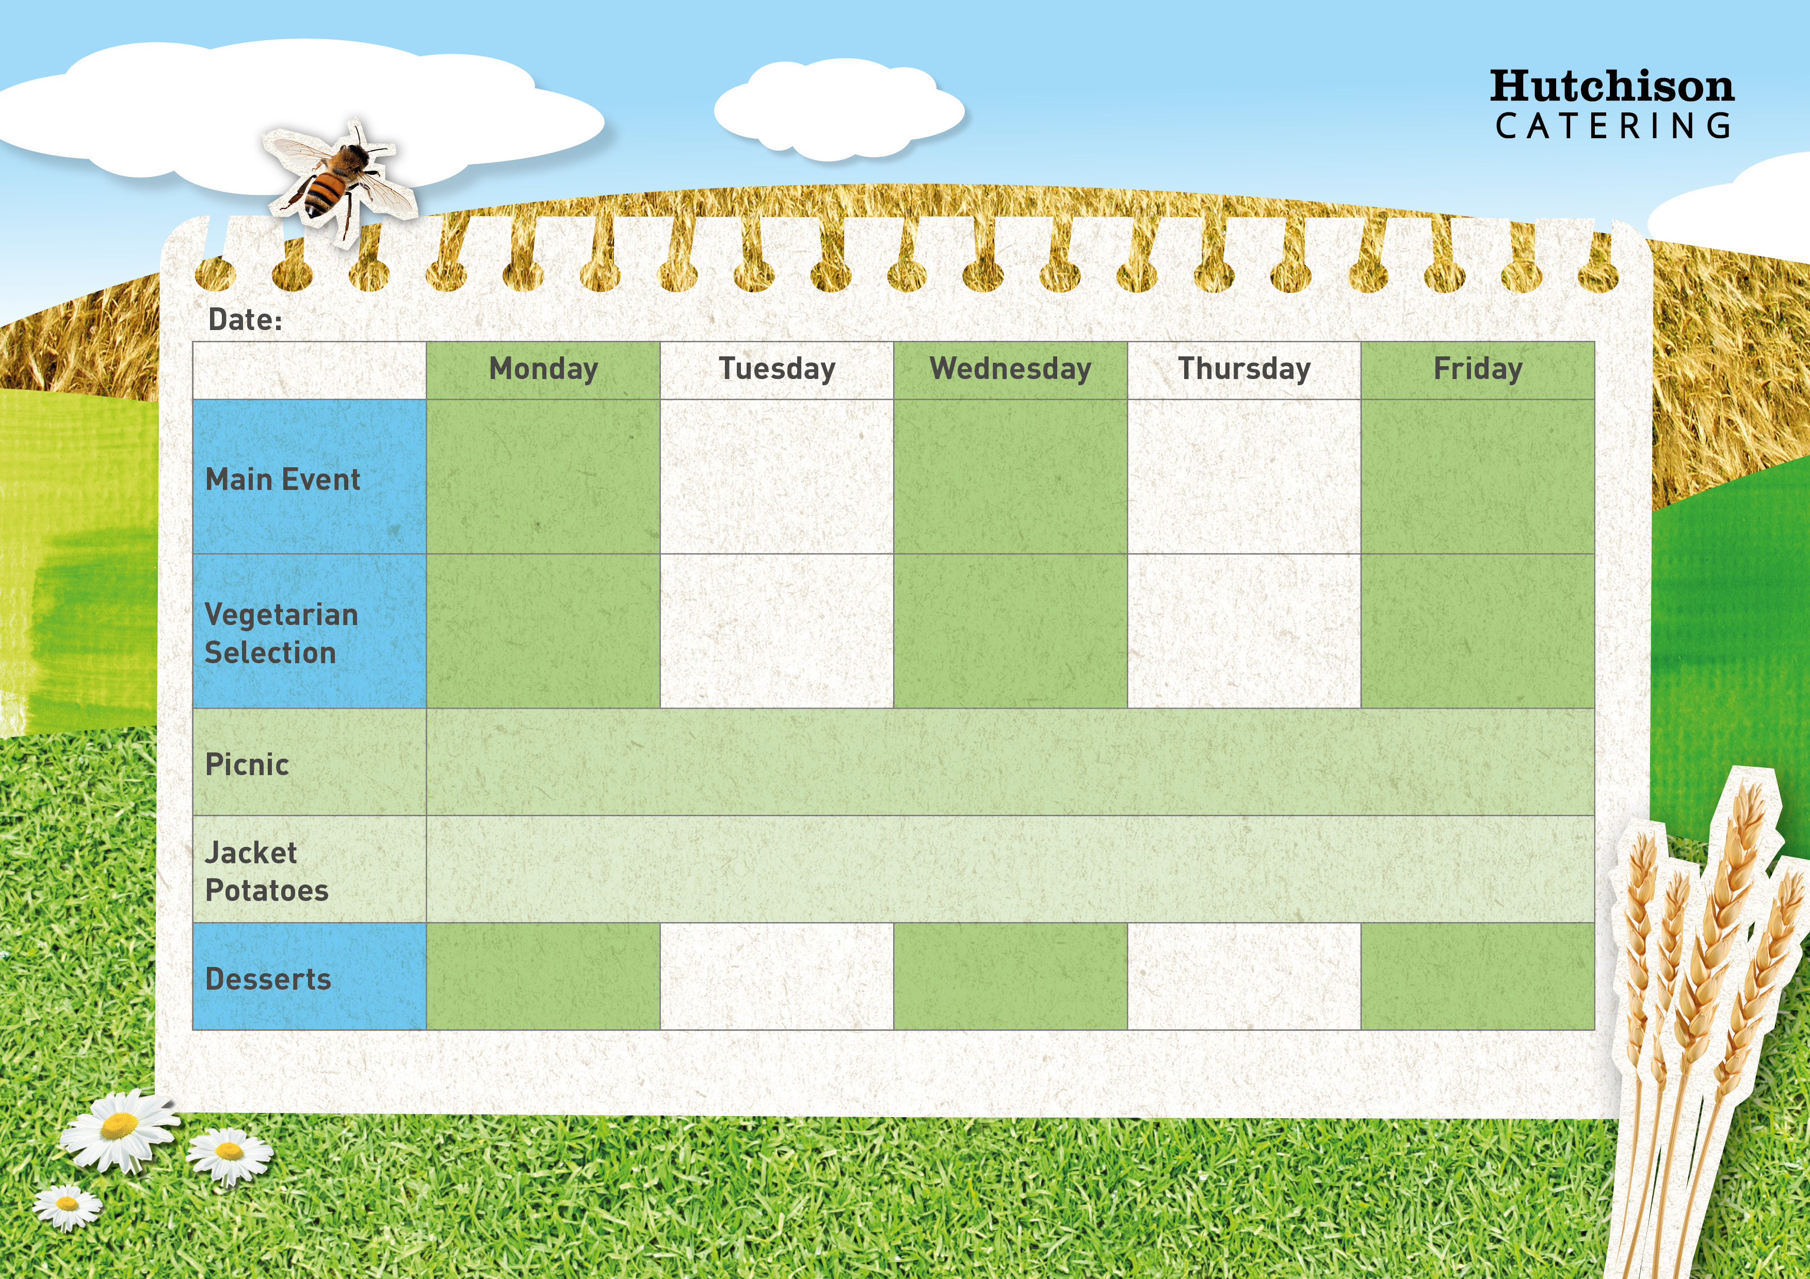

Pork Sausage with, Mash Potatoes, Peas & Gravy

Vegan Sausage Rolls

with Chips & Baked Beans

**Crispy Baked Jacket Potato with a Choice of Cheese, Beans or Tuna**

**Crispy Baked Jacket Potato with a Choice of Cheese, Beans or Tuna**

**Freshly Prepared Baguette**

**Ham/Cheese/Tuna Mayo**

**Crispy Baked Jacket Potato with a Choice of Cheese, Beans or Tuna**

**Spring Week 3**

Veggie Chilli with Rice & Salad

Tomato & Basil Pasta

with Garlic Bread & Broccoli

Roasted Vegetable Pizza with Potato Wedges & Sweetcorn

Ice cream Surprise

Cornflake Cake

Jelly

Chocolate Chip Muffin

**Freshly Prepared Wrap**

**Ham/Cheese/Tuna Mayo**

Crispy Battered Fish with Chips & Baked Beans

Chicken Burger in a bun with Salad & Mayo

Veggie Sausage with Mash Potatoes & Peas & Gravy

Spaghetti & Meatballs in a Tomato Sauce with Garlic Bread & Broccoli

“Meat Free Mondays”

Margarita Pizza with Potato Wedges & Sweetcorn

Flapjack

**All Sandwiches served with Nachos and Freshly Prepared Salad Bar**