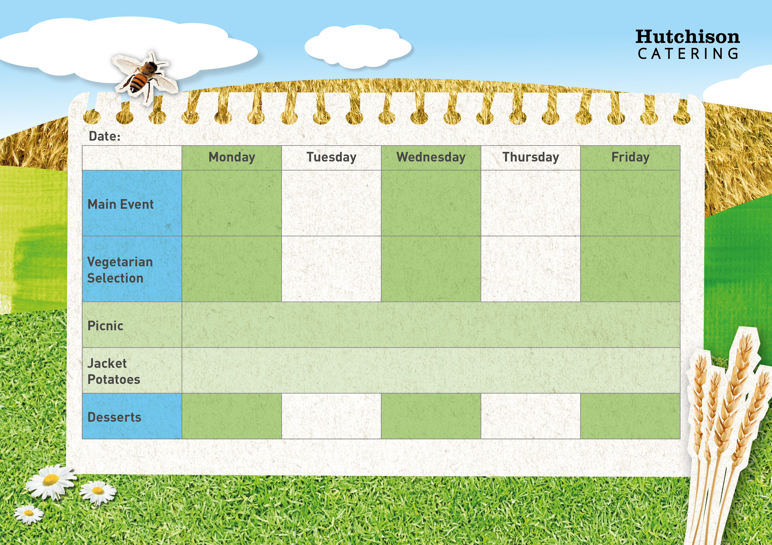

Roasted Vegetable Pizza with Potato Wedges & Sweetcorn

**Freshly Prepared Wrap**

**Ham/Cheese/Tuna Mayo**

**Freshly Prepared Baguette**

**Ham/Cheese/Tuna Mayo**

**Crispy Baked Jacket Potato with a Choice of Cheese, Beans or Tuna**

**Crispy Baked Jacket Potato with a Choice of Cheese, Beans or Tuna**

**Crispy Baked Jacket Potato with a Choice of Cheese, Beans or Tuna**

Homemade Pasta Bolognaise with Garlic Bread & Salad

**Spring Week 2**

All Day Breakfast

Quorn Sausage, Scrambled Egg, Hash Brown, Baked Beans and Buttered Bread

Quorn Fillet with Crispy Roast Potatoes, Carrots & Gravy

Tomato & Basil Pasta with Garlic Bread & Salad

Roast Chicken with Crispy Roast Potatoes, Carrots & Gravy

Quorn Vegan Dippers with Chips & Baked Beans or Peas

Oven Baked Fish Fingers with Chips & Baked Beans or Peas

All Day Breakfast

Sausage, Bacon, Hash Brown, Baked Beans and Buttered Bread

“Meat Free Monday”

Margherita Pizza with Potato Wedges & Sweetcorn

Ice Cream

Chocolate Chip Cookie

Strawberry whip

Chocolate Orange Biscuit

Oaty Bars

**All Sandwiches served with Nachos and Freshly Prepared Salad Bar**