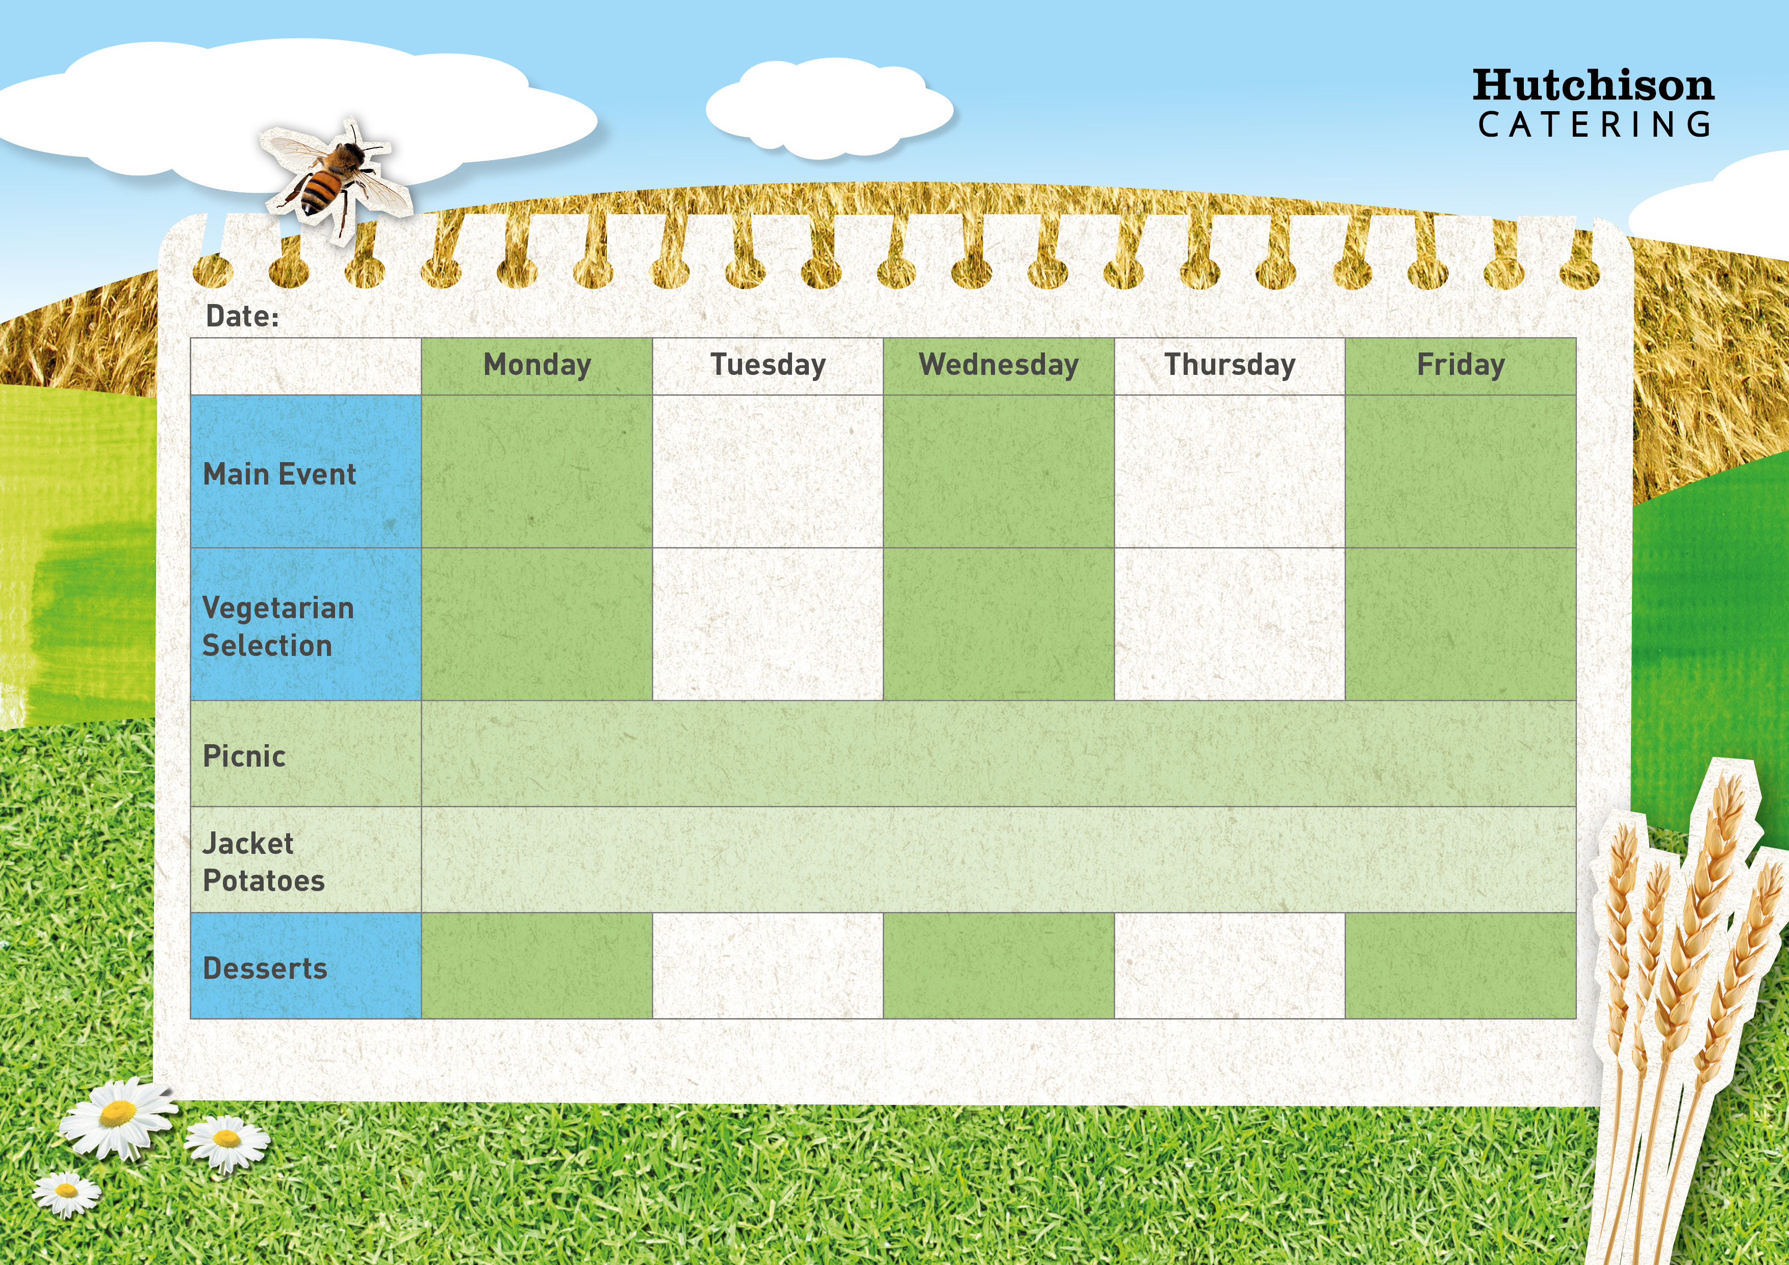

**Crispy Baked Jacket Potato with a Choice of Cheese, Beans or Tuna**

**Crispy Baked Jacket Potato with a Choice of Cheese, Beans or Tuna**

Pepperoni Pasta Bake, with Garlic Bread & Salad

**Crispy Baked Jacket Potato with a Choice of Cheese, Beans or Tuna**

**Freshly Prepared Baguettes**

**Ham/Cheese/Tuna Mayo**

Chicken Korma with Rice, Naan & Sweetcorn

Macaroni Cheese with Garlic Bread & Salad

**Freshly Prepared Wraps**

**Ham/Cheese/Tuna Mayo**

**Spring Week 1**

Vegan Sausage Roll with herby potatoes & beans

Plant Based Meatballs in Gravy with Mash Potato & Broccoli

Gravy

Veggie Korma with Rice

& Sweetcorn

Roast Gammon & Creamy Mash Potato with Gravy & Broccoli

Quorn Burger with Chips & Baked Beans or Peas

Oven Baked Fish Fingers Chips & Baked Beans or Peas

Homemade Sausage Rolls with herby potatoes & beans

Fruit Salad and Ice cream

Chocolate Orange Cake

Summer Berry Jelly

Strawberry Shortbread

Chocolate Crunch

**All Sandwiches served with Nachos and Freshly Prepared Salad Bar**